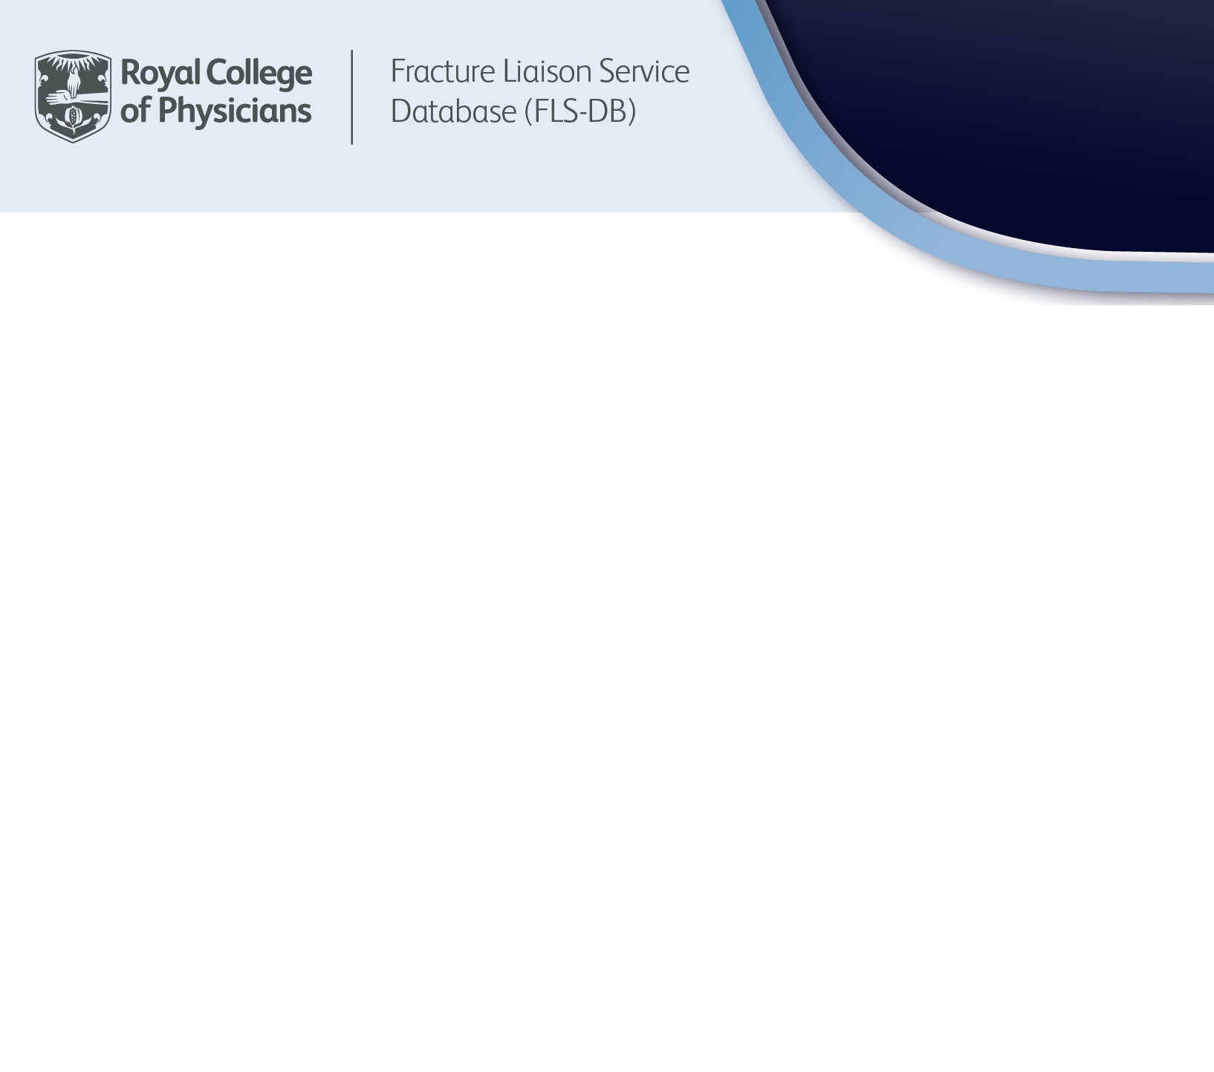

Fracture Liaison Service Database
of England and Wales

A national picture of the ‘missed opportunity’ to prevent future
fragility fractures
The Fracture Liaison Service Database of England and Wales (FLS-DB) is part of the Falls and Fragility Fracture Audit Programme (FFFAP) commissioned by the Health Quality Improvement Partnership (HQIP). FFFAP is a national clinical audit run by the Royal College of Physicians designed to audit the care that patients with fragility fractures and inpatient falls receive in hospital and to facilitate improvement initiatives. In addition to the FLS-DB, FFFAP also runs the National Hip Fracture Database (NHFD) and National Audit of Inpatient Falls (NAIF).

Purpose of this document
From 2024 the FLS-DB aims to extend its reporting for NHS services to every part of England and Wales, rather than being limited to those areas where fracture liaison services (FLSs) are actively participating in the FLS-DB.

In areas with a participating FLS we will highlight how many patients are still not meeting the FLS-DB standards for identification, initiation and continuation of appropriate secondary fracture prevention.

In areas where there is no FLS, we wish to highlight the care gap in secondary prevention of fragility fracture using data from our partner audit, the NHFD, to identify the total number of fragility fracture patients who might have benefited from such secondary prevention if an FLS were in place.

This document aims to ensure that all NHS services and integrated care boards will display their data on the FLS-DB website, helping to identify gaps in care, or where improvements can be implemented. It outlines how the figures on the website will be calculated, showing the total number of people each year – across England and Wales – who miss the opportunity to avoid a further fragility fracture, or complications that can arise from a fracture.

Overview
The FLS-DB captures data on patients over the age of 50 who have sustained a fracture after a fall from standing height or less. These patients are at high risk of having osteoporosis and, if not treated, their bones will get weaker leading to more serious fractures.

Previously, the FLS-DB has only displayed data for patients meeting key performance indicators (KPI) from services that are registered to the audit. As of 2024, the FLS-DB will publish data estimating the number of patients not on treatment at 12 months from services with participating and non-participating FLSs. This will make visible those patients who are not receiving appropriate secondary fracture prevention 12 months after their index fracture at the service and regional level.



How will services be identified?
Registered services are already captured on the FLS-DB website under the benchmarks table. This table demonstrates how services are performing against the KPIs. From the FLS-DB organisational audit, participating FLSs have described which acute hospitals they cover, including where the patients with hip fractures in their locality attend. Acute hospitals that care for hip fracture patients identified in the NHFD and are not covered by the FLS-DB will now be added to the benchmark table.

We have divided services into three groups:

- Group 1: Services registered with the FLS-DB where patients with hip fracture are identified, managed and reported on the FLS-DB website.
- Group 2: Services registered with the FLS-DB where patients with hip fracture are managed separately and not reported on the FLS-DB website
- Group 3: Other sites reporting data to the NHFD, but with no FLS coverage

How are missing patients being identified?
We have selected the number of patients who should be receiving effective secondary prevention
12 months after the index fracture as the key outcome.

To determine the expected number of patients who should be receiving effective secondary prevention 12 months after the index fracture, the local hip fracture records for the last calendar year on the NHFD is multiplied by 5 to estimate the local caseload of patients an FLS could identify. Once you have this figure:

at least 80% of these patients should be identified | of whom at least 50% should be undergoing treatment | of whom at least 80% should start and stay on treatment

A worked example has been included in this excel spreadsheet:

Group 1
Services registered with the FLS-DB where patients with hip fracture are identified, managed and reported on the FLS-DB website:
Calculation:
- NHFD records multiplied by 5
- Minus ‘FLS managed’:
  - The number of FLS-DB records submitted by a registered service
  - Multiplied by the percentage of patients recommended treatment on FLS-DB under KPI 7 (bone treatment recommended)
  - Multiplied by KPI 11 (treatment and adherence at 1 year), but if this is less than 10% then we will use 10%

Group 2
Services registered with the FLS-DB where patients with hip fracture are managed separately and not reported on the FLS-DB website:
Calculation:
- NHFD records multiplied by 5
- Minus ‘FLS managed’:
  - The number of FLS-DB records submitted by a registered service
  - Multiplied by the percentage of patients recommended treatment on FLS-DB under KPI 7 (bone treatment recommended)
  - Multiplied by KPI 11 (treatment and adherence at 1 year), but if this is less than 10% then use 10%
- Minus ‘NHFD managed’:
  - The records submitted under NHFD KPI 7 (to account for hip fractures)

Group 3
Other sites reporting data to the NHFD, but with no FLS coverage:
Calculation:
- NHFD records multiplied by 5
- Minus ‘FLS managed’:
  - The records submitted under NHFD KPI 7 (to account for hip fractures)

Integrated care systems and regional level
The figures for missing patients at regional and integrated care system (ICS) level are:

- Annual missed opportunity (those who should have received secondary care prevention)
- Minus the number who have received secondary care prevention regionally/ICS level

Get in touch
If you have any questions about this document, please get in touch with the FLS-DB team.
If you require support in setting up an FLS, please contact us.

Email: flsdb@rcp.ac.uk
Phone: 020 3075 1511

Title | A national picture of the ‘missed opportunity’ to prevent future fragility fractures
Publication date | 3 December 2024
Review date | 3 December 2025
Description | This document provides an overview of how missing patients are being identified on the FLS-DB website.

This document has been prepared by the FFFAP team:

Kassim Javaid, FLS-DB clinical lead
Antony Johansen, NHFD clinical lead
Rumneet Ghumman, FLS-DB project manager

